

A PROJECT REPORT  
 ON  
 **FACE RECOGNITION TIME ATTENDANCE APPLICATION**

BACHELOR OF COMPUTER SCIENCE  
IN  
SCHOOL OF COMPUTING AND INFORMATICS

SUBMITTED BY

WILLARD OWITI ODONGO P15/141006/2020

SUPERVISED BY

PROF. ELISHA OPIYO [opiyo@uonbi.ac.ke](mailto:opiyo@uonbi.ac.ke)

**DECLARATION**

**ACKNOWLEGDEMENT**

**ABSTRACT**

The face is one of the easiest ways to distinguish the individual identity of each other. Face recognition is a personal identification system that uses personal characteristics of a person to identify the person's identity. Human face recognition procedure basically consists of two phases, namely face detection. Face detection is a software technology that recognizes human faces in digital photos or video frames and is used in a range of applications. This process takes place very rapidly in humans, except under conditions where the object is located at a short distance away, the next is the introduction, which recognize a face as individuals. Stage is then replicated and developed as a model for facial image recognition (face recognition) is one of the much-studied biometrics technology and developed by experts.

The system developed has the capability of identifying participants in the organization holding this software. After face detection, the images of the participants are stored in a database that can be referred to when comparing images during face recognition. Beyond the power of recognition, the application can record the time at which the employees reported to work and the time of check out. High level of customization is embedded into the system where the administrator can control the access the system.

The system is developed as a computer application that can be compatible with windows and Mac operators. The application was developed with Python language and Qt designer. Microsoft Visual Studio was used as an Integrated Development Environment.

Final prototype is tested vigorously and delivered to the end user in time.

Extension: There are vast number of applications from this face detection project, this project can be extended that the various parts in the face can be detect which are in various directions and shapes.

Table of Contents

**Abstract4**

**CHAPTER ONE:**

**Introduction4**

Background7

Face Recognition7

Face Detection8

Real time Face Detection9

Problem Statement9

Objective10

Software Used10

**CHAPTER TWO:**

**Literature Review11**

**CHAPTER THREE:**

**System Analysis and Design13**

Structural Design of the System13

Face Detection Program13

Image matching Program14

Highlighted Faces14

Type chapter title (level 2)2

**CHAPTER FOUR**

**Conclusion17**

CHAPTER ONE

INTRODUCTION

Background:

Security in official places of work have been an issue and employees not reporting to work in time in Kenya majorly. With the help of the system driven by facial recognition, we can bring the betterment of these institutions by increasing the efficiency and security can be improved greatly. The intent of face recognition is to recognize a previously observed item as a known or unknown face. The problems of face recognition and face detection are frequently conflated. Face Recognition, on the other hand, is the process of determining if a "face" belongs to a known or unknown person by utilizing a database of faces to validate the input face.

Face Recognition**:**

DIFFERENT APPROACHES OF FACE RECOGNITION:

There are two predominant approaches to the face recognition problem: Geometric (feature based) and photometric (view based). As researcher interest in face recognition continued, many different algorithms were developed, three of which have been well studied in face recognition literature.

Recognition algorithms can be divided into two main approaches**:**

1. **Geometric:** Is based on geometrical relationship between facial landmarks, or in other words the spatial configuration of facial features. That means that the main geometrical features of the face such as the eyes, nose and mouth are first located and then faces are classified based on various geometrical distances and angles between features. (Figure 3)

2. Photometric stereo**:** Used to recover the shape of an object from several images taken under different lighting conditions. The shape of the recovered object is defined by a gradient map, which is made up of an array of surface normal (Zhao and Chalupa, 2006) (Figure 2)

Popular recognition algorithms include**:**

1. Principal Component Analysis using Eigenfaces, (PCA)

2. Linear Discriminate Analysis,

3. Elastic Bunch Graph Matching using the Fisherface algorithm



FACE DETECTION**:**

Face detection involves separating image windows into two classes: one containing faces (turning the background (clutter). It is difficult because although commonalities exist between faces, they can vary considerably in terms of age, skin colour and facial expression. The problem is further complicated by differing lighting conditions, image qualities and geometries, as well as the possibility of partial occlusion and disguise. An ideal face detector would therefore be able to detect the presence of any face under any set of lighting conditions, upon any background. The face detection task can be broken down into two steps. The first step is a classification task that takes some arbitrary image as input and outputs a binary value of yes or no, indicating whether there are any faces present in the image. The second step is the face localization task that aims to take an image as input and output the location of any face or faces within that image as some bounding box with (x, y, width, height).

The face detection system can be divided into the following steps: -

1. Pre-Processing**:** To reduce the variability in the faces, the images are processed before they are fed into the network. All positive examples that is the face images are obtained by cropping images with frontal faces to include only the front view. All the cropped images are then corrected for lighting through standard algorithms.

2. Classification**:** Neural networks are implemented to classify the images as faces or nonfaces by training on these examples. We use both our implementation of the neural network and the Matlab neural network toolbox for this task. Different network configurations are experimented with to optimize the results.

3. Localization**:** The trained neural network is then used to search for faces in an image and if present localize them in a bounding box. Various Feature of Face on which the work has done on: - Position Scale Orientation Illumination.

### Real Time Face Recognition System

Real-time face recognition involves detection of a face from a series of frames from a video- capturing device. While the hardware requirements for such a system are far more stringent, from a computer vision standpoint, real-time face detection is far simpler process than detecting a face in a static image. This happens due to the continuous motion of people in our surroundings. We walk here and there, blink, play, wave our hands about, etc.

PROBLEM STATEMENT

The Problem statement of Face Recognition for Real-Time Applications are given below:

- To do face recognition in real time.  
- Enhance the Speed i.e., frames/sec.  
- Do recognition on high Camera resolution.

OBJECTIVE

The objectives of Face Recognition for Real-Time Applications are given below:

- To enhance the Frame/sec for Face Recognition System, such that Recognition is done in Real Time.  
- Presently, work on 30frames/sec Our motto is to achieve higher frames/sec or high-Resolution frames/sec.

SIGNIFICANCE OF THE STUDY

This study is preliminary aimed at increasing efficiency in security, this research work will help the users in maintaining data. This system will reduce the rate of fraudulent activities as it can as well keep track of registered users and grant them access upon face recognition completion.

Also, the knowledge that would be obtained from this research will assist the management to grow, also this research work will also be of help to the upcoming researcher in this field of study both with the academic students on their study.

SCOPE OF THE STUDY

The scope of this study covers only on face detection and recognition, accessing previous records and making matched for the data, updating of records, and making delete.

SOFTWARE USED

#### OPEN-CV

Open-CV (Open-Source Computer Vision Library) is an open-source BSD-licensed library that includes several hundreds of computer vision algorithms. Open-CV has a modular structure, which means that the package includes several shared or static libraries.

The following modules are available: -

1. Core Functionality  
2. Image Processing  
3. Video  
4. Calib3D  
5. Features2D  
6. Object  
7. High GUI  
8. Many more

CHAPTER TWO

LITERATURE SURVEY

Face detection is a computer technology that determines the location and size of human face in arbitrary (digital) image. The facial features are detected and any other objects like trees, buildings, and bodies etc are ignored from the digital image. It can be regarded as a ‗specific ‘case of object-class detection, where the task is finding the location and sizes of all objects in an image that belong to a given class. Face detection can be regarded as a more ‗general ‘case of face localization. In face localization, the task is to find the locations and sizes of a known number of faces (usually one). Basically, there are two types of approaches to detect facial part in the given image i.e., feature base and image base approach. Feature base approach tries to extract features of the image and match it against the knowledge of the face features. While image base approach tries to get best match between training and testing images.

CHAPTER THREE

SYSTEM ANALYSIS AND DESIGN

##### Structural Design of the Facial System

The facial recognition program is implemented based on the OpenCV library of the Linux platform. The facial recognition program of this system is completed under the integrated development environment Qt Creator. The program uses multiple functions in OpenCV. Therefore, the OpenCV library must be transplanted to the embedded system, and the program can be executed smoothly. There is a wealth of functions available in the OpenCV library. It can run on operating systems such as Linux/Window/Mac. It provides a variety of algorithms related to image processing and machine vision, and it supports multiple computer programming languages. This system mainly uses the function functions in the two header files in the OpenCV library. cv.h: this header file contains functions that can realize image processing and computer vision and other related functions, such as image processing, pattern recognition, and camera calibration. highgui.h contains the functional functions of user interaction, such as image encoding and decoding, video capture, and GUI interface. The realization of the node function is mainly divided into two parts: face detection and image matching. The following content will describe the program realization of these two parts in detail.[1]

###### Face Detection Program

Face detection is the first step of the facial recognition program, that is, the process of detecting and determining the location of the face from the image collected by the camera and separating the face from the image.A

cv2.VideoCapture(int(*camera_name*))

This function will open the camera after the program is executed and cyclically intercept a frame of the camera’s image. The captured image is stored in the “ImageAttendance“.

###### Image Matching Program

The image matching program is another important part of the realization of the function of the system recognition node. The accuracy of the recognition result directly determines the success of the function. There are mainly the following function calls in the process of program realization.

 match = face_recognition.compare_faces(*encode_list_known*, encodeFace, *tolerance*=0.50)

            face_dis = face_recognition.face_distance(*encode_list_known*, encodeFace)

            name = "unknown"

            best_match_index = np.argmin(face_dis)

            # print("s",best_match_index)

            if match[best_match_index]:

                name = *class_names*[best_match_index].upper()

Highlighted Faces

y1, x2, y2, x1 = faceLoc

                cv2.rectangle(*frame*, (x1, y1), (x2, y2), (255, 0, 0), 2)

                cv2.rectangle(*frame*, (x1, y2 - 20), (x2, y2), (255, 0, 0), cv2.FILLED)

The user does not need to be acknowledged by the system at this point; it merely needs to be detected.

Use Case Diagram

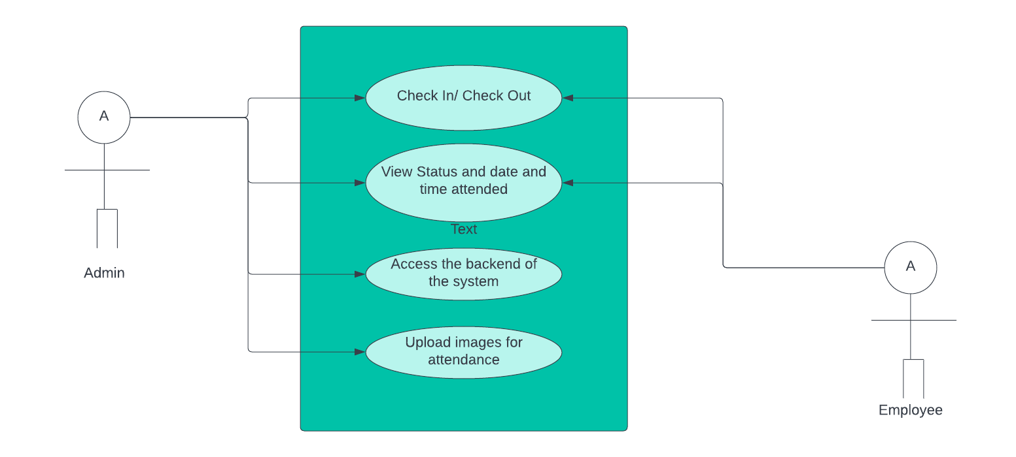

Flow and Processing of the Algorithm

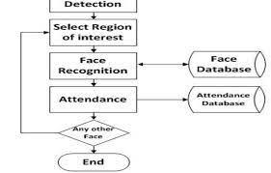

System Block Diagram

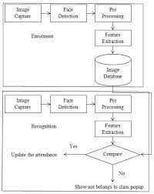

CHAPTER FOUR

Conclusion

The modern technology performs efficient and effective way of handling certain task. As the rise of technologies different sections of industries and companies most have the modern technologies. Industries and companies are the most important of the economy today. [2]

Labour costs area unit one in every of the foremost valuable things in any business. With success dominant, this expense might spell the distinction between success and failure of any organization. All too usually, manual ways of payroll calculation result in inaccuracies and even fraud. Exploitation, associate electronic spreadsheet and doesn't mean accuracy because several of the inputs area units manually encoded the face recognition system is totally automatic because it removes the necessity for a manual calculation.

Employers can appreciate the speed and accuracy of the calculations and can free-up accounting individuals to perform different a lot of productive tasks. Fast forward to these days, facial recognition-based time solutions change organizations to capture worker attendance in period and with high accuracy.

The conception behind this technology weaves AI and machine learning along to make a classy time resolution. The time resolution contains info that's fed with a picture of each worker operating within the organization. Employers will either use existing identification pictures or transfer new ones. Hence, the info becomes a deposit of the complete workforce’s identities stockpiled as baseline pictures.

These pictures are used as distinctive worker signatures. The time resolution makes use of proprietary measures to find an individual's face at intervals a captured image. additionally, it will settle for a vast range of log-IN and log-OUT records per employee per day.

REFERENCES

1. <https://www.hindawi.com>
2. <https://deliverypdf.ssrn.com>